**Assignment -3**

|  |  |
| --- | --- |
| Assignment Date | 01 October 2022 |
| Student Name | HEMALATHA J |
| Student Roll Number | 111519104045 |
| Maximum Marks | 2 Marks |

**Question:1**

Download the Dataset

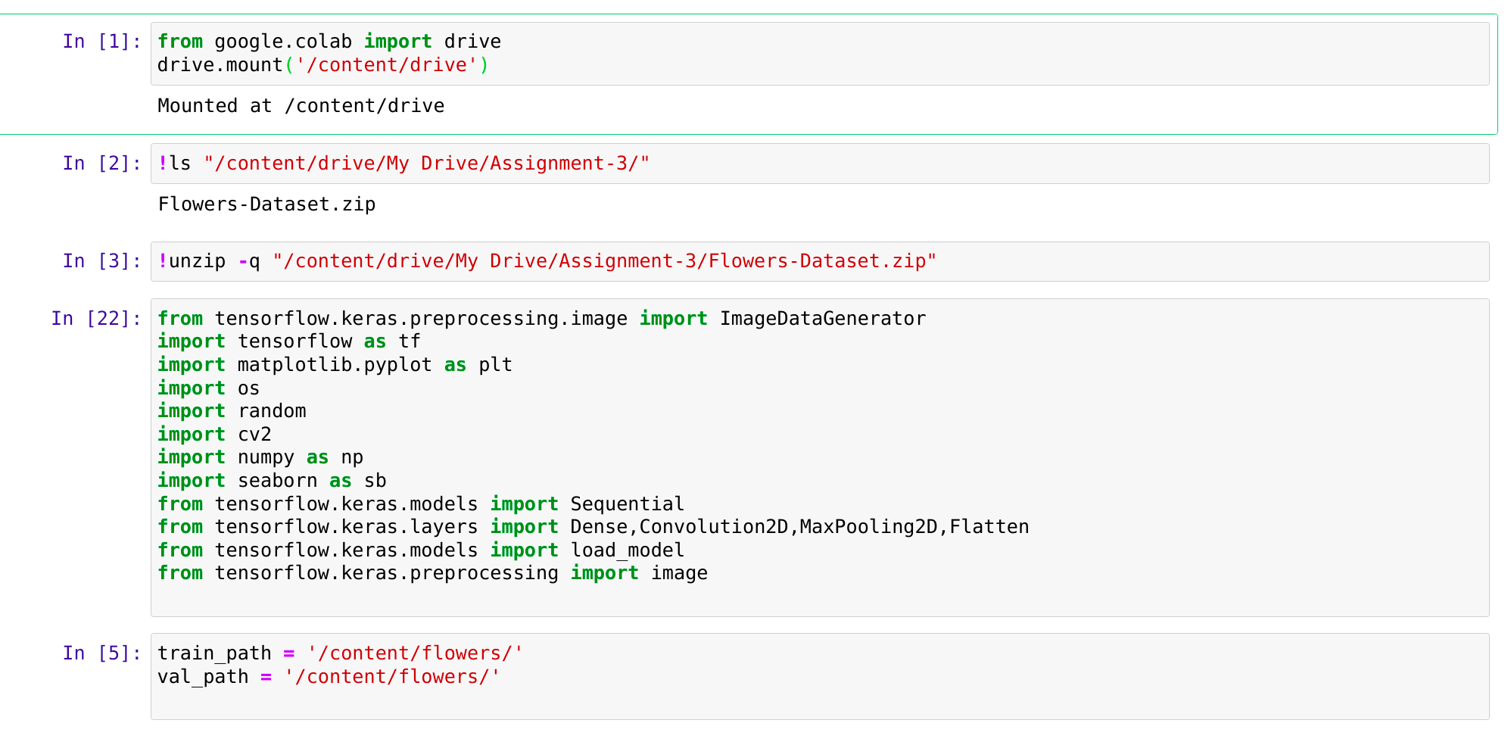Question-2:

Image Augmentation

Solution:

data = ImageDataGenerator(rescale = 1.0/225, zoom_range = 0.2, horizontal_flip = True, vertical_flip = False, validation_split=0.25)

train_data = data.flow_from_directory('/content/flowers/', target_size=(224,224), class_mode = 'categorical', subset= 'training')

test_data = data.flow_from_directory('/content/flowers',target_size=(224,224),class_mode = 'categorical', subset = 'validation')

train_data.class_indices

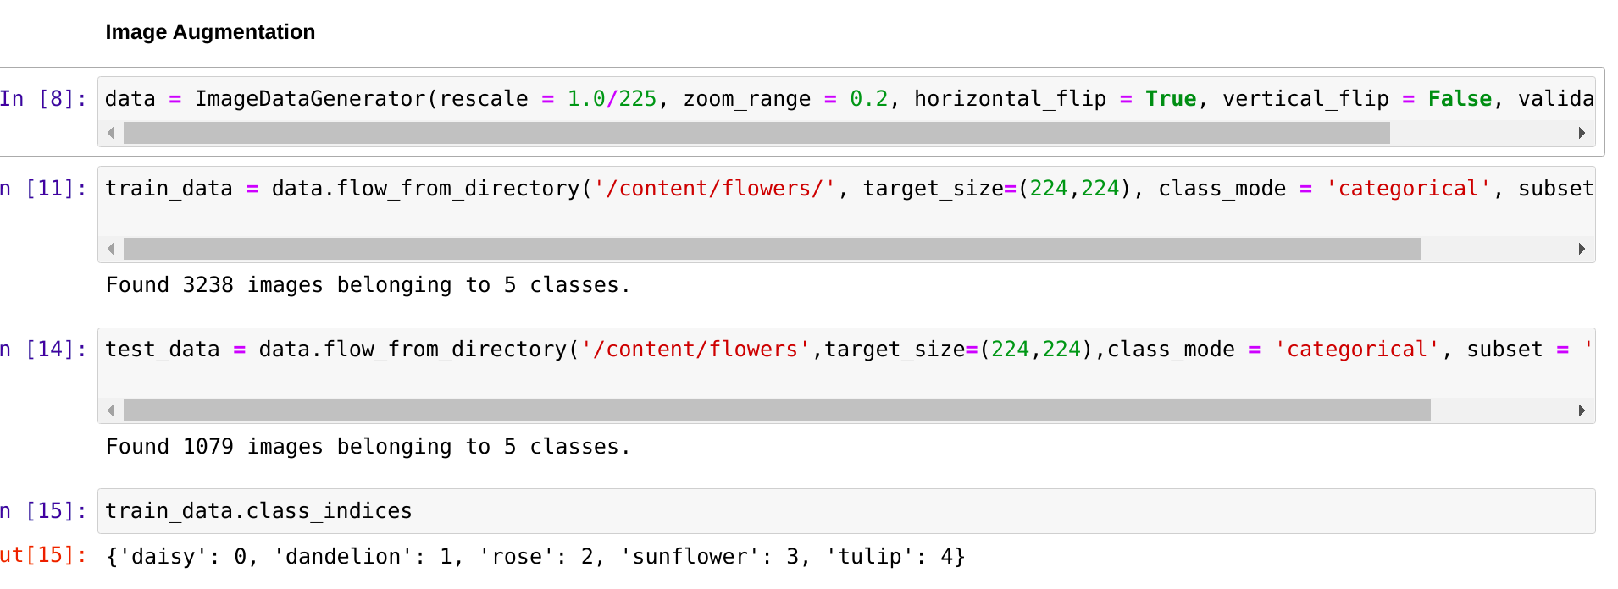

Question-3:

Create Model

Solution :

datamodel = Sequential()



Question-4:

Add Layers

Solution:

datamodel.add(Convolution2D(32,(3,3),input_shape=(224,224,3),activation='relu'))

datamodel.add(MaxPooling2D(pool_size=(2,2)))

datamodel.add(Flatten())

datamodel.add(Dense(300,activation='relu'))

datamodel.add(Dense(150,activation='relu'))

datamodel.add(Dense(5,activation='softmax'))

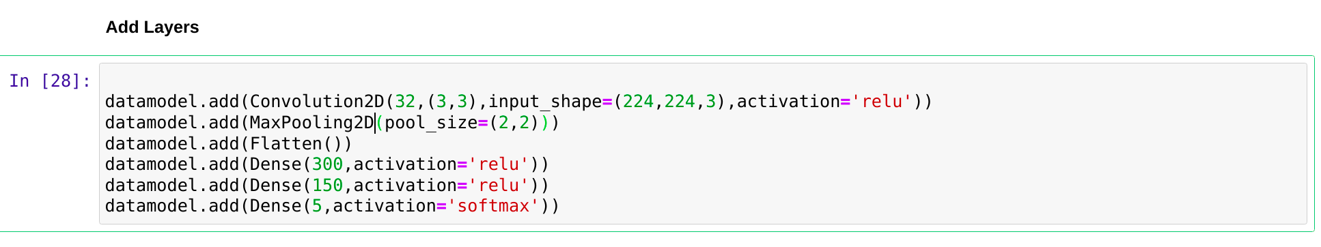

Question-5:

Compile The Model

Soltion:

datamodel.compile(loss='categorical_crossentropy',optimizer='adam',metrics=['accuracy'])



Question -6 :

Fit The Model

Solution :

datamodel.fit(train_data,steps_per_epoch=len(train_data),validation_data=test_data,validation_steps=len(test_data),epochs=15)

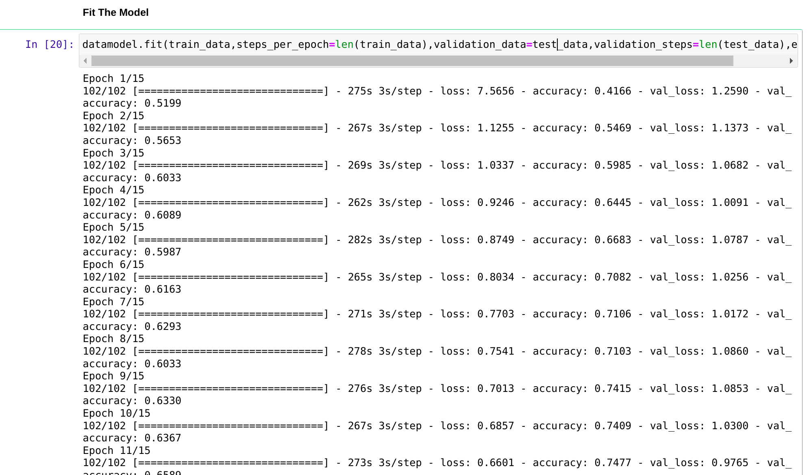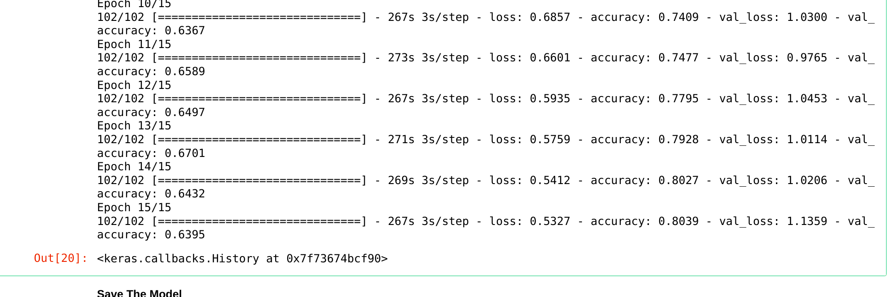

Question-7:

Save the model

solution :

datamodel.save('flowers.h5')



Question-8:

Test The Model

Solution:

img = image.load_img('/content/flowers/dandelion/10437652486_aa86c14985.jpg',target_size=(224,224))

temp_arr = image.img_to_array(img)

dim = np.expand_dims(temp_arr,axis=0)

temp=np.argmax(datamodel.predict(dim),axis=1)

index = ['Daisy','Dandelion','Rose','Sunflower','Tulip']

index[temp[0]]

